WORLD PIANO TEACHERS ASSOCIATION WPTA ARGENTINA
INTERNATIONAL PIANO COMPETITION IPC 2022
ONLINE Edition
Application Procedure
Composition Category

To apply to WPTA Argentina IPC 2022, follow this procedure:

- APPLICATION FEE

Process online application payment:

Platform PayPal (from Argentina may require authorization from your bank and issuing card) https://www.paypal.com/cgi-bin/webscr?cmd=_s-xclick&hosted_button_id=68V5GLBAWMYUA

Before completing the payment, you must agree to the number of apps registered in your shopping cart, as well as the total amount you are paying. After successfully processing the payments from the corresponding registration, you will receive a confirmation email. Send this confirmation email to wpta.argentina@gmail.com and be sure to keep the original email received, as you will need it to complete the application form.

- RULES CATEGORY COMPOSITION WPTA Argentina IPC 2022 AND APPLICATION FORM

Open attachments (or similar downloaded online) about the WPTA Argentina IPC 2022 Composition Category Rules and also the Application Form. Read both documents to understand all the essential information and to organize and complete the application form. We recommend that you save the Application Form locally to your computer, so that you can return to it when you need it to fully complete all required fields. Preferably use the Word version of the application form and feel free to adjust any field to customize the form and transmit any specific information.
3) APPLYING YOUR REQUEST

Send us the following documents by email to wpta.argentina@gmail.com

a) copy of the corresponding payment confirmation email from your application.
b) complete Application Form
c) -score (mandatory) of the part sent for WPTA ARGENTINA IPC 2022
-recording (recommended with instruments)
For more details see item number 15 of Rules Category Composers and Application Form.
d) Color photography (suitable for high definition publications, suggested higher than 1000 pixels)
e) Brief biography/CV

Please contact us if you have any questions.
We look forward to your participation in the WPTA Argentina IPC 2022

M° Sergio René Martínez, President of WPTA IPC Argentina
Mª Nélida Sánchez, Artistic Director of WPTA IPC Argentina
M° Fabrizio Danei, Executive Director of WPTA IPC Argentina
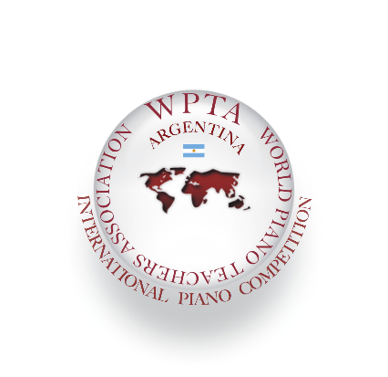

International Piano and Composition Competition
WPTA Argentina IPC 2022 Online Edition
Autonomous City of Buenos Aires CABA - Argentina

Contact: wpta.argentina@gmail.com
www.wpta.info/argentina/en

Competition website. Download files for online application: www.wpta.info/argentina/ipc-en/

