International Piano and Composition Competition
WPTA Argentina FCP IPC 2022
Online Edition

WORLD PIANO TEACHERS ASSOCIATION
WPTA ARGENTINA
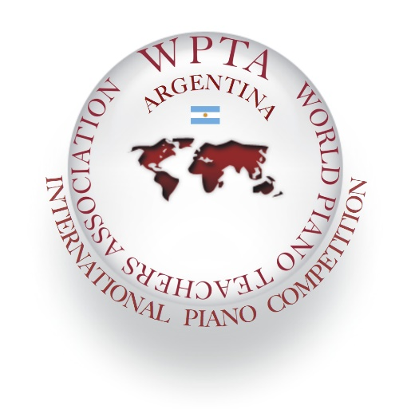
"Giving musical artists their rightful place:
Worldwide recognition!"

Dear Pianists and Composers,

World Piano Teachers Association WPTA Argentina and Fundación Cultural Patagonia FCP, invite your participation at their International Piano Competition in Performance and Composition Category, from the age of twelve with no age or nationality limit to be held in Online Edition.

World Piano Teachers Association WPTA International, is a member of the Alink-Argerich Foundation which gathers the most prestigious international competitions.

It is a competition in which our mission is: "To achieve worldwide recognition for musical artists!"

In this new edition we invite pianists to participate in a new category "ARGENTINA AWARD for CURRENT PIANISTIC CREATION" performing a work by an Argentine composer who is a member of the AAC Argentine Association of Composers.

The International Jury is made up of worldwide renowned Pianists and Composers:

M° Fabrizio Danei (Jury member in Performance category, Argentina)

M° Giuseppe Devastato (Honorary Jury member in Performance and Composition category, Italy-Spain)

M° Achille Gallo (Honorary Jury member in Performance category, Italy)

M° Daniel Goldstein (Jury member in Performance category, Argentina)

M° José Luis Juri (Jury member in Performance category, Argentina)

M° Sergio René Martínez (Jury member in Performance and Composition category, Argentina)

Mª Marcela Pavia (Honorary Jury member in Composition category, Argentina-Italy)

Mª Nélida Sánchez (Jury member in Performance category, Argentina)

The WPTA Argentina FCP IPC competition provides the perfect opportunity to establish networks and contact with influential pianists, composers, and artists around the world.

WPTA Argentina FCP IPC 2022 will be held on the following dates:

July 4, 2022: Contest application begins.
October 31, 2022: Contest application deadline.
November 2022: Laureates are announced.

From December 2022: Awards Ceremony (online or presential), Gala Concerts, and presentations, to be held during the WPTA Argentina FCP IPC 2022, in Buenos Aires and Río Negro, on the dates to be informed by the competition organization. All presentations in theatres, with the public present, are subject and according to the possibilities of sanitary regulations established by the national authorities in 2022, related to the global covid-19 pandemic.

To download rules, forms, and online application for the WPTA Argentina FCP IPC 2022 competition visit the web site:

www.wpta.info/argentina/ipc-en/

For more information please contact:

wpta.argentina@gmail.com

We highly recommend that you sign up for this exciting event that can enhance your careers in many ways.

Please contact us for all information.

Our best regards,

M° Sergio René Martínez, President of WPTA Argentina
Mª Nélida Sánchez, Artistic Director of WPTA Argentina
M° Fabrizio Danei, Executive Director of WPTA Argentina
Architect Norberto Rajneri, President of the Fundación Cultural Patagonia
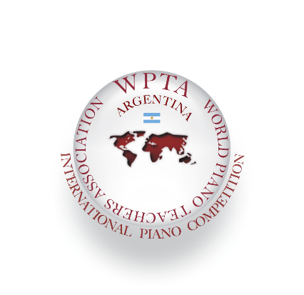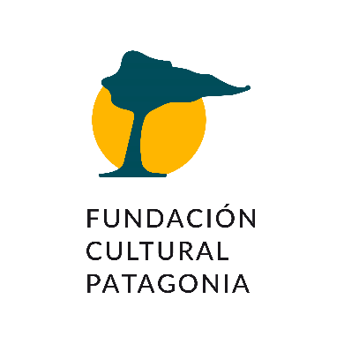
International Piano and Composition Competition WPTA Argentina FCP - IPC 2022
City of Buenos Aires CABA-City of General Roca, Province of Río Negro

Contact: wpta.argentina@gmail.com
www.wpta.info/argentina/en

