WORLD PIANO TEACHERS ASSOCIATION WPTA ARGENTINA
INTERNATIONAL PIANO COMPETITION IPC
RULES
PERFORMANCE CATEGORY
About the competition

1. The International Piano Competition WPTA Argentina IPC FVT, is organized by the Argentine national association of WPTA and the Valta Thorsen Foundation.
World Piano Teachers Association (WPTA) is a member of the Alink-Argerich Foundation.

2. The WPTA Argentina IPC FVT is open to performers of all nationalities without age limit. Young performers are encouraged to apply, as well as emerging and established interpreters seeking more promotion and opportunities.

3. The mission of the WPTA Argentina IPC FVT is to provide the laureates with high-level performance opportunities before an audience of world-class pianists, professors and critics as well as members of the general public. Furthermore, its aim is to encourage and promote educational and social interaction between young pianists and established professionals.

4. The winners in Piano performance, will be presented as soloists in the Salón Dorado, Teatro Colón (Golden Hall of the world-renowned Columbus Theatre) in Buenos Aires, at the Gala Concert of the WPTA Argentina IPC FVT Awards.
- The 1st Prize in performance will receive a free application to the WPTA IPC 2019 International Piano Competition in Novi Sad, Serbia, home of WPTA International (www.wpta.info/ipc), where the World Piano Conference will be held, and in a successful result in 2019, you will have your costs trip and stay covered to give a Concert Gala as the winner of the IPC 2019 Competition at the WPC (World Piano Conference) in Novi Sad, Serbia.
- The 1st Prize in Performance will receive an exclusive Master Class with a World Class Pianist; the winner of the first prize will be informed the day of the laureates announcement in the Competition, the prize will be awarded and communicated to the winner, by the Valta Thorsen Foundation (fundacionvaltathorsen.org).
- The 1st Prize in performance will also receive the scheduled presentation of a solo piano recital invited by WPTA Argentina Rio Negro Patagonian Arts, together with the Patagonia Cultural Foundation (www.fcp.org.ar), in Gral. Roca, Río Negro, pole of the musical and artistic cultural activity in Patagonia Argentina, where the first level artists of argentine musical scene participates, with costs of stay covered.

Auditioning

5. Applicants will be auditioned in one of the following ways:
- Audiovisual recording of its performance: it is mandatory to send an audiovisual recording (video) live, a movement, or a complete work without any edition, and with a record age not exceeding two years as the maximum limit at the time of submitting to the competition, accompanied by the program of the concert where it was recorded, with information describing the concert hall and date. As an example, a complete sonata movement, a complete prelude and fugue, a complete concert movement, or complete work, etc., without any sound or visual editing. You can accompany the initial material live, with another made in a recording studio, with similar characteristics, a complete movement, or integral work, and with a record age of no more than two years as the maximum limit at the time of presenting the contest. Send it by email, the online links with the video recording, such as Youtube, Vimeo, or similar (preferred); also Wetransfer, Dropbox, Google Drive, or other similar storage service.

An International Jury, both in Argentina and in other countries, constituted by artists of great prestige and national and international trajectory, will make the evaluation of the material sent to compete.
Only in case of need to be audited by a judge appointed by WPTA, will be contacting WPTA Argentina IPC FVT to organize an audition. The audition must be done after having paid the online application fee. Be sure to facilitate the recording of the audition (audio only), as you must send the recording to your judge by email after the audition (the judge will then send the recording to WPTA Argentina IPC FVT). Keep in mind that recording the live audition is your responsibility and not the responsibility of the judge. However, in some cases, the judge may agree to organize a recording and send it directly to us. The judge will also send us the grade of evaluation and other details of the audition.
If the judge is already familiar with your performance, you can send us the evaluation grade without audition. In this case (or in the case that you are applying without being evaluated or audited by a local judge), you must send us an audiovisual recording of your performance (either as a link published on the web or as an email attachment). Please see the details in the WPTA Argentina IPC FVT Rules.
6. The audition program (sent as an audio-visual recording live, in video, and the recording) must consist of a minimum of 20 minutes, preferably of well-contrasted repertoire each. Web links and audio-visual recordings must clearly show the performer in a live and any part edited.

Applicacions

7. The deadline for the application to the WPTA Argentina IPC FVT competition: August 31, 2018
8. The results of the competition: the winners will be announced September 2, 2018
9. The following application materials should be sent to WPTA Argentina IPC FVT by email (wpta.argentina@gmail.com):
A) Completed Application Form (attached in the mail)
B) for the purpose of audition, one of the following:
  - web-link/Dropbox-link (or similar service) of the applicant’s performance
- audio-visual recording of the applicant’s performance: it is mandatory to send an audiovisual recording (video) live, a movement, or a complete work without any edition, and with a record age not exceeding two years as the maximum limit at the time of submitting to the competition, accompanied by the program of the concert where it was recorded, with information describing the concert hall and date. As an example, a complete sonata movement, a complete prelude and fugue, a complete concert movement, or complete work, etc., without any sound or visual editing. You can accompany the initial material live, with another made in a recording studio, with similar characteristics, a complete movement, or integral work, and with a record age of no more than two years as the maximum limit at the time of presenting the contest. Send it by email the online links with the video recording, such as Youtube, Vimeo, or similar (preferred); also Wetransfer, Dropbox, Google Drive, or other similar storage service.
- A combination of web-link(s) and audio-video recording(s), sent by email, is permitted.
C) colour photograph (suitable for publishing, higher than 1000 pixels)
D) biography in English/Spanish
E) proof of paid application fee (€ 50) by forwarding the electronic remittance slip to: wpta.argentina@gmail.com
In order to process the application fee, please visit the following web-link:
https://www.paypal.com/cgi-bin/webscr?cmd=_s-xclick&hosted_button_id=68V5GLBAWMYUA

10. Applicants can use the same web-link/recording or live audition for more than one edition of the WPTA Argentina IPC. In such cases, only the materials under A and E are required.

WPTA Argentina IPC FVT Program Requirements

11. Applicants to the Interpretation category will be able to perform a piano recital with a program that will preferably include in the repertoire, the works submitted to the competition, in the case of the winners.
12. The Piano Recital program can be one of the following, it depends on the organization and availability on the date of the Awards Gala Concert:
a) short recital (30 - 40 minutes)
b) full recital (65 - 75 minutes, to include 55 - 65 minutes of music and a 10 minute interval)
13. The choice of repertoire, order of works in the program and the use of repeats are left to the performers' discretion.
14. Solo recitals, must be performed from memory (except for non-standard / modern works).

Prizes

15. The winners in Piano performance, will be presented as soloists in the Salón Dorado, Teatro Colón (Golden Hall of the world-renowned Columbus Theatre) in Buenos Aires, at the Gala Concert of the WPTA Argentina IPC FVT Awards.
- The 1st Prize in performance will receive a free application to the WPTA IPC 2019 International Piano Competition in Novi Sad, Serbia, home of WPTA International (www.wpta.info/ipc), where the World Piano Conference will be held, and in a successful result in 2019, you will have your costs trip and stay covered to give a Concert Gala as the winner of the IPC 2019 Competition at the WPC (World Piano Conference) in Novi Sad, Serbia.
- The 1st Prize in Performance will receive an exclusive Master Class with a World Class Pianist; the winner of the first prize will be informed the day of the laureates announcement in the Competition, prize that will be awarded and communicated to the winner, by the Valta Thorsen Foundation (fundacionvaltathorsen.org).
- The 1st Prize in performance will also receive the scheduled presentation of a solo piano recital invited by WPTA Argentina Rio Negro Patagonian Arts, together with the Patagonia Cultural Foundation (www.fcp.org.ar), in Gral. Roca, Río Negro, pole of the musical and artistic cultural activity in Patagonia Argentina, where the first level artists of argentine musical scene participates, with costs of stay covered.
All laureates will also receive:
- International Diploma by WPTA Argentina IPC FVT 2018 Laureate
- Total exemption from the fee for attending concerts, presentations and conferences of the WPC World Piano Conference.
- WPTA Argentina membership and custom logo (suitable for publication and online distribution).
16. The jury can award as many WPTA Argentina IPC FVT International Piano Competition Laureate titles as it finds appropriate.
17. Laureates are expected to be available to perform during the Gala Concert on September 14, 2018. Failure to be available for the requested date will result in the withdrawal of the prize. Under special circumstances laureates can request to perform at a later World Piano Conference WPC. The approval of these requests is at the sole discretion of the WPTA Argentina IPC FVT and cannot be contested.

Competition Jury

18. The competition jury will be comprised of internationally recognized musicians.
19. The jury’s decisions are final and are not subject to appeal. By signing the Application Form, a competitor accepts the WPTA Argentina IPC FVT rules and the decisions of the competition jury.

Miscellaneous details

20. The WPTA Argentina IPC reserves the right to record, videotape and broadcast the complete WPTA Argentina IPC WPC performances without payment to the laureates. Recordings are the permanent property of the WPTA IPC and it is free to use them as it wishes.
21. Some foreign nationals may need a visa for their entry in Argentina.

Please contact us if you have any questions.

We look forward to your participation in the WPTA ARGENTINA IPC FVT

M° Sergio René Martínez, President WPTA IPC WPC Argentina
Mª Nélida Sánchez, Artístic Director WPTA IPC WPC Argentina
M° Fabrizio Danei, Executive Director WPTA IPC WPC Argentina
Mrs. Salua Gavilanes, Valta Thorsen Foundation FVT, President

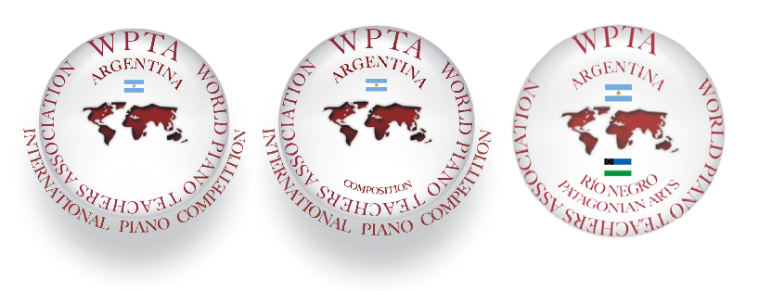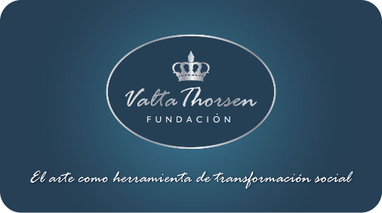

International Piano and Composition Competition WPTA Argentina IPC FVT 2018
Salón Dorado (Golden Hall) Teatro Colón (Columbus Theatre) Buenos Aires, Argentina

Contact: wpta.argentina@gmail.com
www.wpta.info/argentina

IPC Competition Website. Download Bases online: www.wpta.info/argentina/ipc

