WORLD PIANO TEACHERS ASSOCIATION WPTA ARGENTINA
INTERNATIONAL PIANO COMPETITION IPC 2021
ONLINE Edition
Application Procedure
Category PERFORMANCE

To apply to the WPTA Argentina IPC 2021, follow this procedure:

1) APPLICATION FEE

Process online application request payment:

Paypal platform (from Argentina may require authorization from your bank and issuing card)
https://www.paypal.com/cgi-bin/webscr?cmd=_s-xclick&hosted_button_id=68V5GLBAWMYUA

Before completing the payment, you must agree to the number of applications registered in your shopping cart, as well as the total amount you are paying.
After successfully processing the corresponding registration payments, you will receive a confirmation email.
Please send this confirmation email to wpta.argentina@gmail.com and be sure to keep the original email received, as you will need it to complete the application form.

2) RULES CATEGORY INTERPRETATION WPTA Argentina IPC 2021 AND APPLICATION FORM

Open the attached files (or similar files downloaded online) about the WPTA Argentina IPC 2021 Interpretation Category Rules and the Request Form.
Please read both documents to understand all essential information and to get organized and fill out the application form. We recommend saving the Application Form locally on your computer, so that you can return to it when needed to fully complete all required fields. Preferably use the Word version of the request form and feel free to adjust any field to customize the form and convey any specific information.

3) AUDITION AND EVALUATION

The auditions and evaluations will be through sending the online link of the video as detailed in points number 9, 10, 11, 12 and 13 on the file Rules Category Performance of the competition.

4) APPLYING YOUR APPLICATION

Email us the following documents at wpta.argentina@gmail.com

a) copy of the confirmation email of the corresponding payment of your application.
b) Complete application form
c) Online link of the audio-visual recording of your performance.
d) Photograph of the contestant in colour (suitable for high-definition publications, suggested above 1000 pixels)
e) Brief biography / CV

Please do not hesitate to contact us if you have any questions.

We look forward to your participation in the WPTA ARGENTINA FCP - IPC 2021

M° Sergio René Martínez, President of WPTA IPC Argentina
Mª Nélida Sánchez, Artistic Director of WPTA IPC Argentina
M° Fabrizio Danei, Executive Director of WPTA IPC Argentina
Architect Norberto Rajneri, President of Fundación Cultural Patagonia
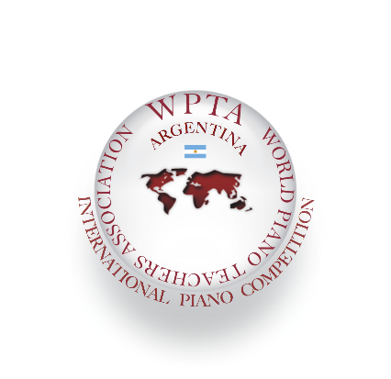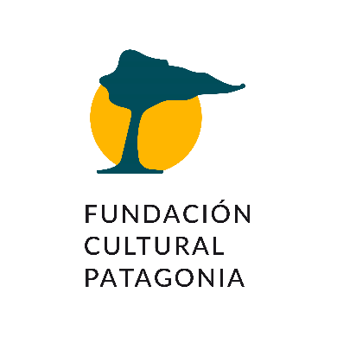

International Piano and Composition Competition
WPTA Argentina IPC 2021 Online Edition
Autonomous City of Buenos Aires CABA - Argentina

Contact: wpta.argentina@gmail.com
www.wpta.info/argentina/en

Competition website. Download files for online application: www.wpta.info/argentina/ipc-en/

