WPTA (World Piano Teacher Association) USA-FL presents
International Online WPTA-USA-FL Baroque Keyboard Workshop (harpsichord, clavichord, organ, piano) will be held on Saturday, April 11, 2020
BKW open for an online private masterclass to the state, national and international professionals, college, pre-college, and amateurs of any ages, qualifications, and levels, with the keyboard experience of 3+ years.

It’s been the first time in 100 years when J.S. Bach’s Passion was heard under conducting by F. Mendelsohn. This performance marked the rediscovery of Bach as a composer, and a revival of his works began, obviously, in the romantic style. At the beginning of the 20th c. the revision was made with a shift to exclusively classical, strict style of performance. However, at the beginning of the 20th c. Sol Babitz’s Early Music Laboratory made first attempts to interpret Baroque music authentically. Since then, Baroque scholars have been intensively exploring Baroque fundamentals based on the treatises of the 16th to the middle 18th c. and present to music performers more sources for the historically informed interpretations of Bach/Baroque compositions in the most possibly adequate to period way based on the latest researches results.
Currently, it’s a well-known fact that performing the Baroque repertoire historically is established as a necessary requirement at any major piano auditions and competitions over the world.
Repertoire may include any Baroque piece starting from Anna Magdalena Bach to J.S. Bach’s Partitas … Early Classical period compositions are accepted as well (J. S. Bach’s sons, early Haydn and Mozart).
Clinicians:
Peter Sykes - Associate Professor of Music, Harpsichord, Organ, Clavichord, and Fortepiano; Chair, Historical Performance at Boston University, Boston, MA; faculty at Julliard Conservatory, New York, NY; harpsichordist and organist of the First Church in Boston, MA
David Buice - Musical Director of the Lutheran Church in Seattle, CA, Co-Director of Atlanta Baroque Keyboard Workshop of The Atlanta Early Music Alliance, harpsichordist, conductor, and organist

The fee: 30 min. lesson - $50, 60 min. lesson -- $75.
Upload Forms, apply, and pay by PayPal online at http://www.wpta.info/usa-florida/, at the page Event, Baroque Keyboard Workshop Registration
Students will receive International WPTA-USA-FL Certificate
Teachers of applied students: enroll and pay the annual fee of $25 for WPTA membership at http://www.wpta.info/usa-florida/ to be invited to the World Piano Conference in Novi Sad, Serbia.

Please refer questions to Ex. Director, President of WPTA USA-FL association Raisa Isaacs at risaacsmusic@gmail.com
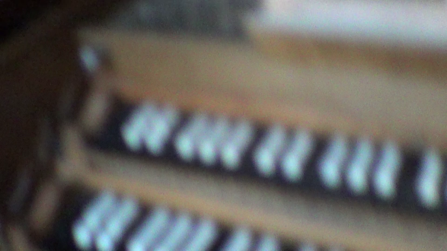

Harpsichord of Blandine Verlet, France (2017).

https://www.facebook.com/WorldPianoTeachersAssociation/
http://www.wpta.info/usa-florida/

