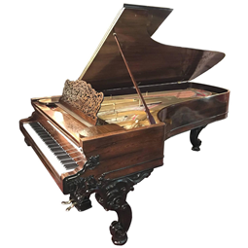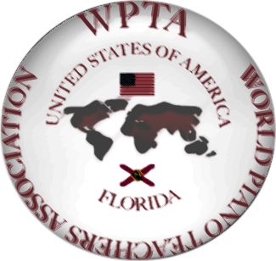 The World Piano Teachers Association USA-Florida association announces
International Romantic Piano Competition (Online)
Upload deadline – April 5, 2020.
Open for Pre-college and College students, Adult Professionals, and Amateur Adults (no age limitation)
All WPTA USA and Florida associations, independent teachers, students, and amateurs, state, interstate, and international applicants are welcome!
Participants are required to submit a video recording for the audition. The 1st, 2nd, 3rd, and Honorable Mention winners will be chosen in each age category. Accordingly to the time limitation, Applicants might select one or two pieces of the different composers of the Romantic period.
Performers will be judged on their sensitivity, individuality, and expression.
Winners will be awarded medals and International Diplomas. The best performances will be uploaded on the WPTA-USA-FLORIDA website.
Teachers will be awarded Certificates of Recognition of the WPTA-USA-FLORIDA International Competition.
Apply and pay by PayPal online at http://www.wpta.info/usa-florida/#events:
WPTA-USA-FL International Piano Competition of the Romantic Music, Application Form.
Paypal at the tabs: Application Fee-Member, Application Fee—Non Member
Fees are non-refundable. (Please NOTE that applications without immediately paid fees online will not be accepted.)
Teachers presenting their students at the competition are welcomed to become Members of the World Piano Teachers Association (WPTA) residing in Novi Sad, Serbia at http://www.wpta.info/usa-florida (in the area MEMBERSHIP click $25 to enroll).
Students of the teacher, who is a member of WPTA USA-Florida, will pay the discounted Application fee.
Adult students are welcome to join WPTA and receive the Application discount as well.
Please upload your video on Youtube only.
The participants will be judged by the Interantional jury.
If you have any questions, please contact the WPTA-USA-FLORIDA President and chairperson, Dr. Raisa Isaacs, at risaacsmusic@yourpianoteacher.com

