WORLD PIANO TEACHERS ASSOCIATION WPTA ARGENTINA
INTERNATIONAL PIANO COMPETITION IPC
APPLICATION PROCEDURE - COMPOSERS
In order to apply for the WPTA Argentina IPC, please follow this procedure:
- APPLICATION FEE
Process the application fee(s) online:

https://www.paypal.com/cgi-bin/webscr?cmd=_s-xclick&hosted_button_id=68V5GLBAWMYUA

Before completing the payment, you should be satisfied with number of registration fees in your shopping basket, as well as the total amount you are paying.
After successfully processing the registration fee(s), you will get a confirmation email. Please forward this confirmation email to:
wpta.argentina@gmail.com
and make sure to keep the original email received, as you will need it in order to complete the application
form.
2) WPTA Argentina IPC RULES AND APPLICATION FORM
Please for the Composition Rules and Application Form write to:
wpta.argentina@gmail.com
Please visit the WPTA Argentina IPC page:
http://www.wpta.info/argentina/ipc
Download the WPTA Argentina IPC Rules and Application Form.
Please read both documents to understand all essential information and get organized for completing the Application Form.
We recommend saving the Application Form locally on your computer, so you can revert to it as you need in order, to fully complete all required fields.
Please use the Word version of the Application Form, and feel free to adjust any fields in order, to personalize the Form and convey any specific information.
If you are applying with more than one entry, you can use one Application Form.
3)APPLYING
Please send us the following documents by email to wpta.argentina@gmail.com :
a) copy of the registration fee payment confirmation email
- fully completed Application Form
- for the purpose of audition, one of the following:
  - web/Dropbox link(s) of your performance (please specify on the Application Form)
  - audio-visual recording of your performance (please send by email or use the Dropbox or similar service)
  - name of the WPTA Argentina-appointed judge who is going to hear you in a live audition
(completed on the Application Form)
- colour photograph (suitable for publishing, greater than 1000 pixels)
- biography in English
If you are to undertake a live audition with a WPTA Argentina-appointed judge, we will await the recording and assessment grade from them.
You will then receive the confirmation from WPTA Argentina IPC by email confirming you as a contestant.
Please do not hesitate to contact us should you have any enquiries.
We look forward to your participation at the WPTA Argentina IPC.
Kind regards,
WPTA Argentina IPC

M ° Sergio René Martínez, WPTA Argentina IPC WPC President
Mª Nélida Sánchez, WPTA Argentina IPC WPC Artistic Director
M ° Fabrizio Danei, WPTA Argentina IPC WPC Executive Director
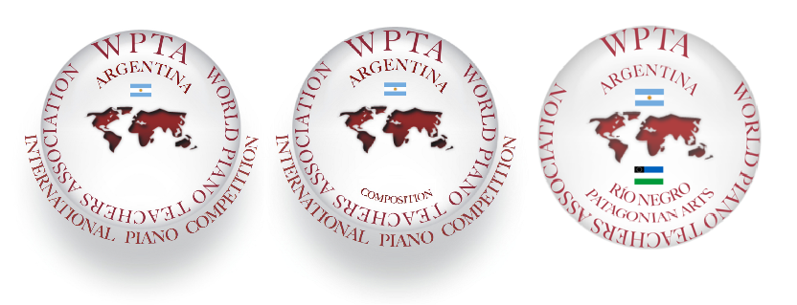

International Piano Competition IPC WPTA Argentina 2018.
Salón Dorado, Teatro Colón (Golden Hall, Columbus Theatre) Buenos Aires, Argentina

Email: wpta.argentina@gmail.com
Web: http://www.wpta.info/argentina
http://www.wpta.info/argentina/ipc
sergioremartinez@yahoo.com.ar
Movile: (+54) 9 11 51071476
Phone: (+54) 11 44893260
nelidasanchezpiano@hotmail.com
Movile: (+54) 9 11 58278657
Phone: (+54) 11 45225857
fabriziodanei@gmail.com
Movile: (+54) 9 298 4903461

