WORLD PIANO TEACHERS ASSOCIATION WPTA ARGENTINA
INTERNATIONAL PIANO COMPETITION IPC
VALTA THORSEN FOUNDATION FVT
RULES
COMPOSITION CATEGORY
About the competition

- The International Piano Competition WPTA Argentina IPC, is organized by the Argentine national association of WPTA.
World Piano Teachers Association (WPTA) is a member of the Alink-Argerich Foundation.

- The mission of the WPTA Argentina IPC is open to composers of all nationalities (including stateless candidates) without age limit. Young composers are encouraged to apply, as are emerging and established composers who seek further promotion and opportunities.
- The mission of the WPTA Argentina IPC is to provide the laureates with high-level promotion opportunities before an audience of world-class musicians, pianists, professors and critics as well as members of the general public.
4. The winners in Piano Composition, will be presented as awarded at the Salón Dorado, Teatro Colón.
(Golden Hall of the world-renowned Columbus Theatre) in Buenos Aires, at the Gala Concert of the WPTA Argentina IPC Awards.
The 1st Piano Composition Prize will be able to perform its winning work at the Laureate Gala Concert.
The 1st Piano Composition Prize will also receive a free application to the WPC 2019 World Piano Conference in Novi Sad, Serbia, home of WPTA International, where the International Conference with a first level pianists, pedagogues and composers will be held; a repertoire of his works in a live performance; or in multimedia material for presentation in absentia, without the need for transfer, integrating the WPTA international catalog WPC 2019 together with leading international artists participating at the World Piano Conference. In case of a live performance the cost of travel and stay will be at your expense.

Applications
- Application deadline is August 31.
- Competition results will be announced by September 2.
- The following application materials are to be sent to WPTA Argentina IPC by email (wpta.argentina@gmail.com):
- completed Application Form available for download at
wpta.argentina@gmail.com
www.wpta.info/argentina/ipc
B) at least one of the following:
  - score of the piece being submitted for the WPTA Argentina IPC
  - recording of the piece being submitted for the WPTA Argentina IPC (via youtube, Dropbox or other online service, or as email attachment)
C) colour photograph (suitable for publishing, higher than 1000 pixels)
D) biography in English/Spanish
E) proof of paid application fee (€ 50) by forwarding the electronic remittance slip to:
wpta.argentina@gmail.com
In order to process the application fee, please visit the following web-link:
https://www.paypal.com/cgi-bin/webscr?cmd=_s-xclick&hosted_button_id=68V5GLBAWMYUA
8. Applicants can use the same web-link/recording or live audition for more than one edition of the WPTA Argentina IPC. In such cases, only the materials under A and E are required.

WPTA Argentina IPC Program Requirements

9. Applicants can submit the score of any piece of music (of any length) that includes piano (e.g. piece for piano solo, piano concerto or similar work for piano and orchestra, chamber music which includes piano etc.). All applicants (regardless of the type of piece submitted) will be adjudicated together.
10.Published and unpublished pieces are equally welcome.
11. Pieces submitted for the WPTA Argentina IPC can have been previously performed or not yet performed.
12.Pieces of any style or aesthetic direction are acceptable.
13.By signing the application form, a composer testifies that the piece submitted for the WPTA Argentina IPC is their own, original work.
14.Applicants can compete with more than one piece concurrently. Separate applications are required for each piece.

Prizes
15. The winners in Piano Composition, will be presented as awarded at the Salón Dorado, Teatro Colón.
(Golden Hall of the world-renowned Columbus Theatre) in Buenos Aires, at the Gala Concert of the WPTA Argentina IPC Awards.
The 1st Piano Composition Prize will be able to perform its winning work at the Laureate Gala Concert.
The 1st Piano Composition Prize will also receive a free application to the WPC 2019 World Piano Conference in Novi Sad, Serbia, home of WPTA International, where the International Conference with a first level pianists, pedagogues and composers will be held; a repertoire of his works in a live performance; or in multimedia material for presentation in absentia, without the need for transfer, integrating the WPTA international catalog WPC 2019 together with leading international artists participating at the World Piano Conference. In case of a live performance the cost of travel and stay will be at your expense.
International WPTA Argentina IPC Laureate’s Diploma
16.Jury can award as many WPTA Argentina IPC International Piano Competition Laureate titles as it finds appropriate. Each laureate will receive the complete award package as described above.

Competition jury
17.The competition jury will be comprised of internationally recognized musicians.
18.The jury’s decisions are final and are not subject to appeal. By signing the Application Form, a competitor accepts the WPTA Argentina IPC rules and the decisions of the competition jury.

Miscellaneous details
19.The WPTA Argentina IPC reserves the right to record, videotape and broadcast the complete WPTA Argentina IPC WPC performances without payment to the laureates. Recordings are the permanent property of the WPTA Argentina IPC and it is free to use them as it wishes.
20. 21. Some foreign nationals may need a visa for their entry in Argentina.
Please contact us if you have any questions.

We look forward to your participation in the WPTA ARGENTINA IPC FVT

M° Sergio René Martínez, President WPTA IPC WPC Argentina
Mª Nélida Sánchez, Artístic Director WPTA IPC WPC Argentina
M° Fabrizio Danei, Executive Director WPTA IPC WPC Argentina
Mrs. Salua Gavilanes, Valta Thorsen Foundation FVT, President

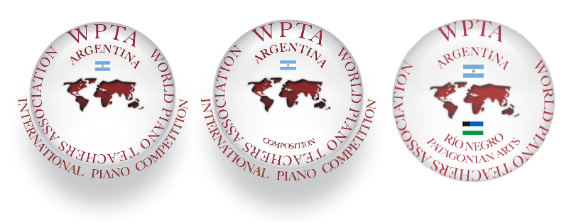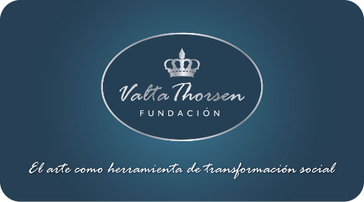

International Piano and Composition Competition WPTA Argentina IPC FVT 2018
Salón Dorado (Golden Hall) Teatro Colón (Columbus Theatre) Buenos Aires, Argentina

Contact: wpta.argentina@gmail.com
www.wpta.info/argentina

IPC Competition Website. Download Bases online: www.wpta.info/argentina/ipc

